**Que 2} What is OOP? List OOP concepts**

* **OOP stands for Object Oriented Programming.**
* **Following is OOP concepts:**

**1.Class**

**2.Object**

**3.Inheritance**

**4.Polymorphisam**

**5.Encpsulation**

**6.Abstraction**

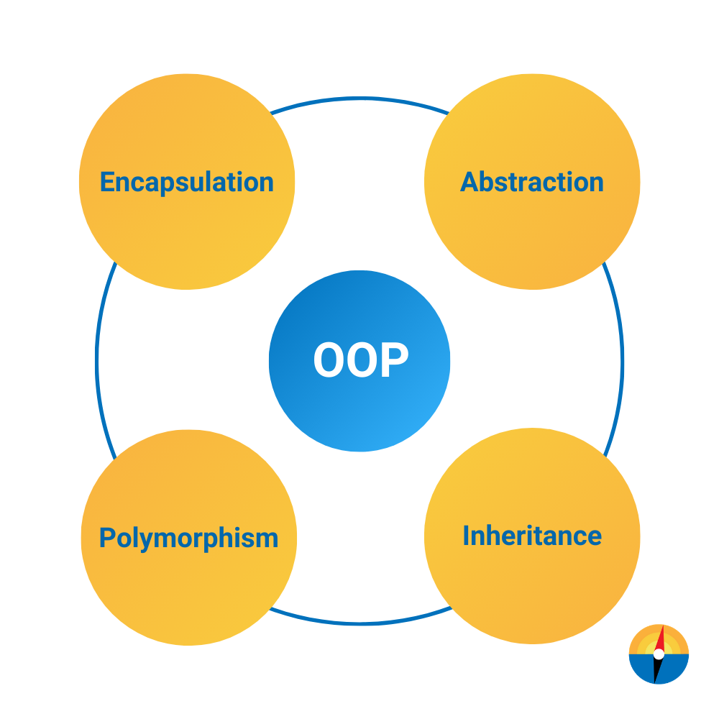

**Que 3} What is the difference between OOP and POP?**

**\* OOP :-**

**-Object – oriented.**

**-The Program is divided into objects.**

**-Bottom up approch.**

**-Inheritance property is used.**

**-It uses an access specifiers.**

**-Encapsulation is used to hide the data.**

**-Concept of virtual Function.**

**-C++,Java, Python.**

**\* POP :-**

**-Structure Oriented.**

**-Program is divided into functions.**

**-Top down approch.**

**-Inheritance is not allowd.**

**-It dosen’t use an access specifires.**

**-No data hiding is done.**

**-No virtual Functions.**

**-C, Pascal.**